***Database Systems Lab 9 Assignment***

Name = Poorab Gangwani

Class = 4B1

Roll-Number = CS191092

Tables:

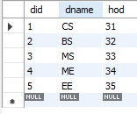

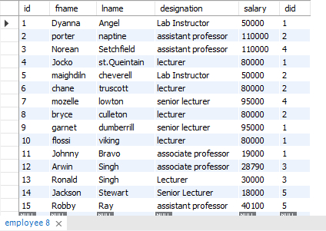

Task 1

1. Display the minimum of the average salaries of all departments.

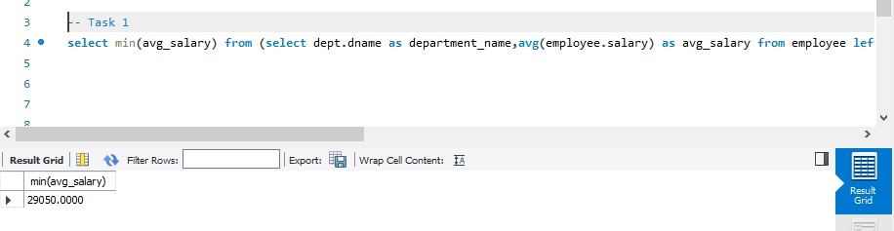

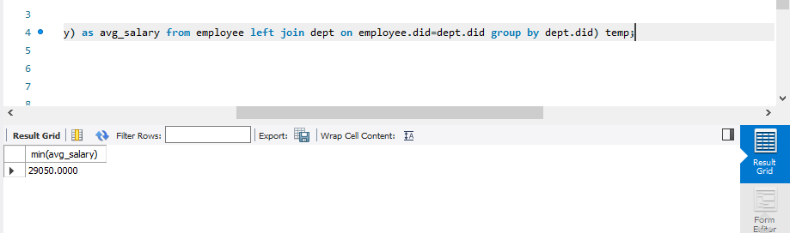

Task 2

1. Display the percentage of salary expense for each department.

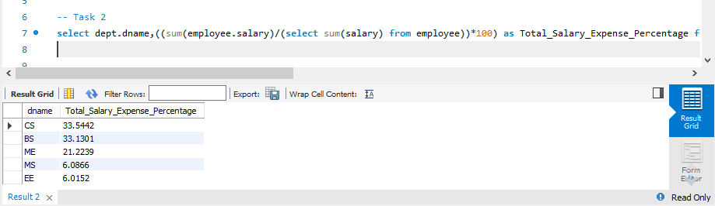

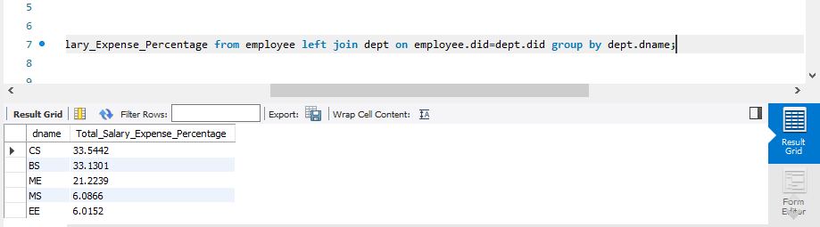

Task 3

1. Insert into a new table, lowsalary, the names, designations, salaries, and departments of all the employees with salary less than 60000.

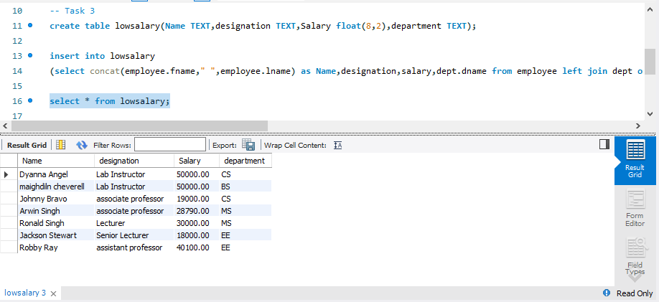

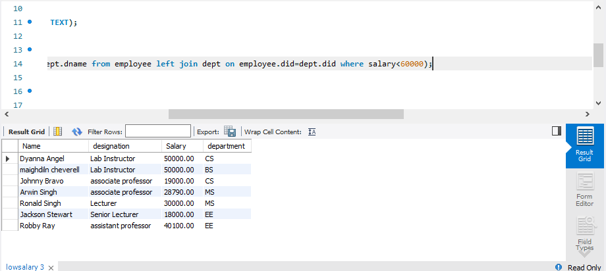

Task 4

1. Display the names of all the departments whose average salary is greater than the average salary of the company.

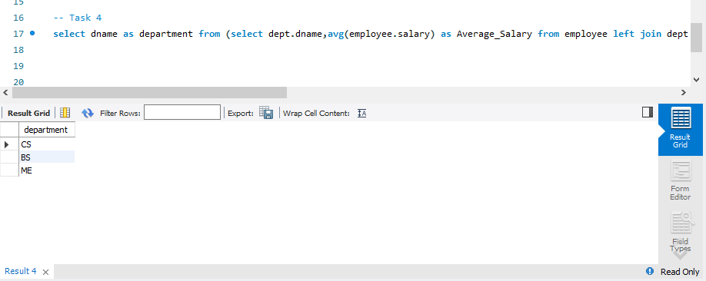

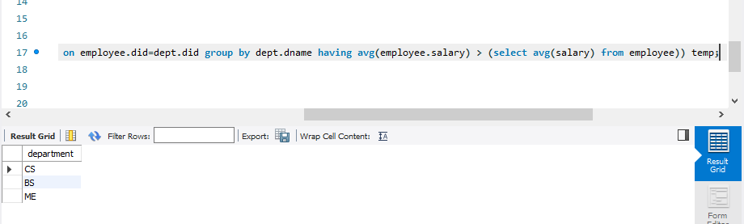

Task 5

1. Display the name of the departments whose average salary is highest among the departments whose average salaries are less than the average salary of the company.

